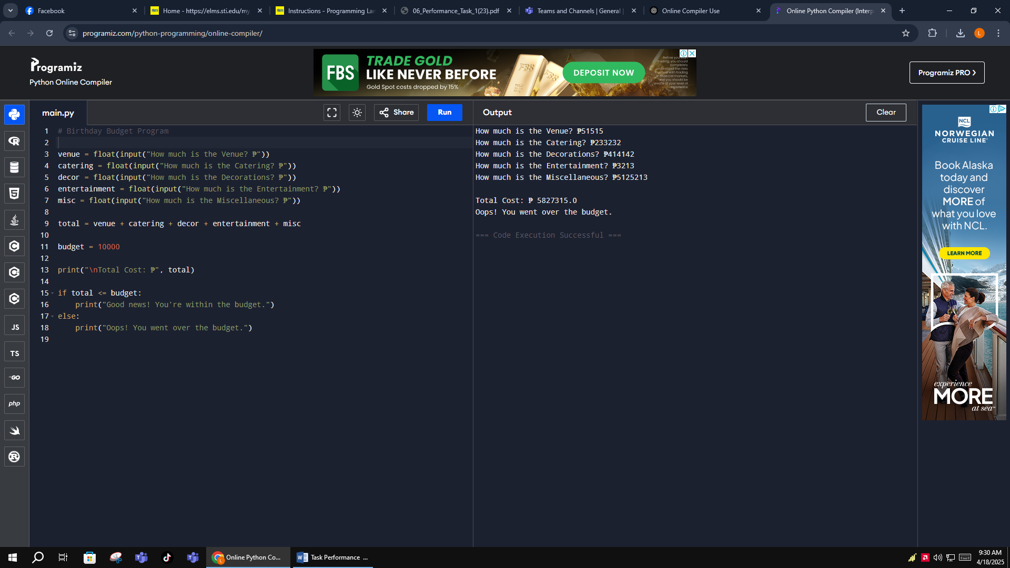

# Birthday Budget Program

venue = float(input("How much is the Venue? ₱"))

catering = float(input("How much is the Catering? ₱"))

decor = float(input("How much is the Decorations? ₱"))

entertainment = float(input("How much is the Entertainment? ₱"))

misc = float(input("How much is the Miscellaneous? ₱"))

total = venue + catering + decor + entertainment + misc

budget = 10000

print("\nTotal Cost: ₱", total)

if total <= budget:

print("Good news! You're within the budget.")

else:

print("Oops! You went over the budget.")